UI/UX Professional Certification Project
Kotak Mahindra Bank — Mobile App Redesign

Submitted by: Chetan Prajapat
File: ACE_Project_ChetanPrajapat
Course: BCA 4th Sem BCA
College: Sage university indore
Enrolment no: 24COA2BCA0044

Figma Link: https://www.figma.com/proto/6WDLqj26qnlP1EvTbG3vbF/Untitled?node-id=17-2&p=f&t=90hBkOkzDRDgnO7T-0&scaling=scale-down&content-scaling=fixed&page-id=0%3A1

1. Analysis of Existing App Screens
Screen 1 — Home Dashboard (Problems Found)
- Visual clutter: Header is overcrowded — balance, logo, and greeting all compete for attention.
- Low contrast: Grey text on white background fails WCAG 2.1 AA contrast ratio (4.5:1 minimum).
- Small touch targets: Quick Action icons (Send, Scan QR, Recharge) are below the 44x44dp minimum.
- Color-only transaction labels: Red/green amounts are inaccessible to colorblind users.
- Dense transaction list: No clear spacing between items; date text is too small to read easily.

Screen 2 — Payment Success (Problems Found)
- Dead-end screen: No 'Share Receipt', 'Download PDF', or 'Back to Home' button — user is stuck.
- False affordance: The 'From Accounts' dropdown on a read-only screen confuses users.
- No copy functionality: UPI Transaction ID and Reference ID cannot be copied with a tap.
- Missing next steps: No clear CTA after a successful payment.
2. Redesign Goals
- Simplify navigation — consolidate overlapping paths (Payments tab vs Send Money quick action).
- Improve readability — establish a clear font hierarchy; increase contrast to meet accessibility standards.
- Fix dead-end flows — add CTAs on the success screen: Share, Download PDF, Return to Home.
- Modernize UI — use consistent card styles, spacing, and icons while keeping Kotak's red brand color.
- Increase accessibility — add icon + color dual indicators for debit/credit; min touch target 48dp.

3. Design System
Color Palette
Color Name | HEX | Usage
Kotak Red (Primary) | #C0392B | Headers, primary buttons, highlights
Dark Red (Pressed) | #922B21 | Button hover/active states
White | #FFFFFF | Backgrounds, card surfaces
Light Grey | #F2F3F4 | Page background, input fields
Success Green | #1E8449 | Credit amounts, success icons
Info Blue | #2E86C1 | Links, secondary buttons, copy icons
Dark Text | #1A1A2E | Primary body text
Secondary Text | #5D6D7E | Labels, captions, timestamps

Typography
Style | Size | Usage
Display (Balance) | 32sp Bold | Account balance, hero amounts
Heading 1 | 24sp SemiBold | Screen titles, section headers
Body Primary | 16sp Regular | Transaction names, content
Caption | 12sp Regular | Timestamps, account numbers

Font: Inter. Chosen for excellent mobile legibility and wide numeral support.

Spacing & Components
- Base unit: 4dp. All spacing is a multiple of 4.
- Screen padding: 16dp horizontal. Card internal padding: 16dp.
- Touch targets: Minimum 48x48dp for all tappable elements.
- Cards: 16dp border radius, 2dp shadow (rgba 0,0,0,0.08), white background.
- Buttons: Primary = Red fill + white text. Secondary = Red outline. Height: 48dp.

4. Navigation Structure
Current Problems
- 'Payments' tab and 'Send Money' Quick Action serve the same purpose — redundant.
- No direct 'Accounts' section in bottom nav — users have to find it from a home screen widget.
- Payment success screen has zero navigation options.

Redesigned Bottom Navigation
Tab | What's Inside
Home | Balance overview, Quick Actions, Recent Transactions
Pay | Send Money, Receive, Scan QR, Bill Payments — all in one place
Accounts | Savings Account, Fixed Deposits, UPI Wallet
More | Cards, Loans, Settings, Profile

Core Task Flow: Home tap Pay tab tap Select recipient tap Enter amount tap Confirm PIN = Payment Done (5 taps max).

5. Key Design Decisions & Rationale
Design Decision | Why This Was Done
Simplified header — only balance + greeting + profile icon | Removes visual clutter; balance is the #1 priority for users opening the app
Quick Actions as large icon+label tiles (56x56dp) | Touch targets now exceed 44dp minimum; labels remove icon ambiguity
Debit/Credit shown with icon + color (not color alone) | Fixes colorblindness accessibility issue — 300M+ Indians are colorblind
Added 3 CTAs on success screen (Share / Download / Home) | Eliminates the dead-end flow; covers all user needs post-payment
Copy icon next to Transaction ID & Reference ID | Standard pattern (GPay, PhonePe); users copy IDs for dispute resolution
Removed 'From Accounts' dropdown on success screen | Read-only screen needs no dropdown — replaced with a simple info line
Figma Design Link
Figma Prototype: https://www.figma.com/proto/6WDLqj26qnlP1EvTbG3vbF/Untitled?node-id=17-2&p=f&t=90hBkOkzDRDgnO7T-0&scaling=scale-down&content-scaling=fixed&page-id=0%3A1
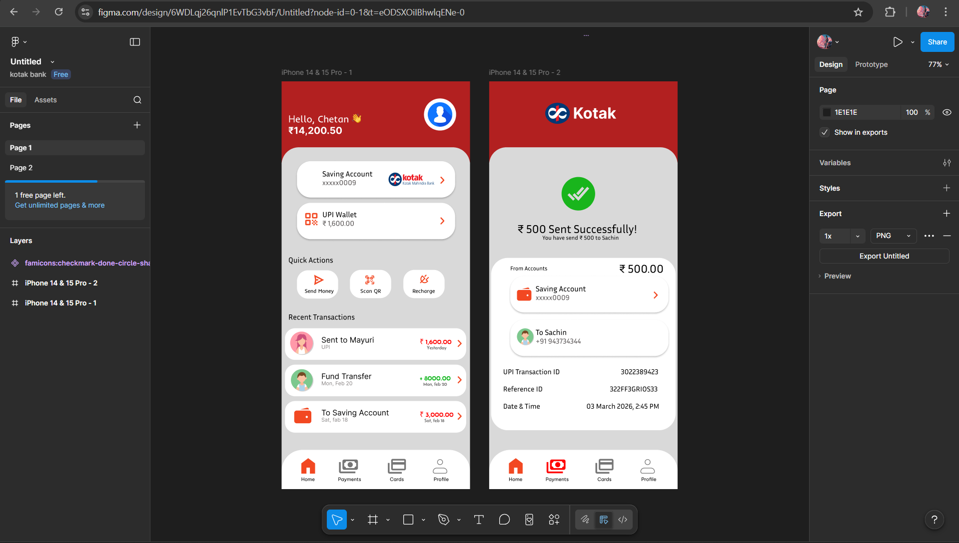

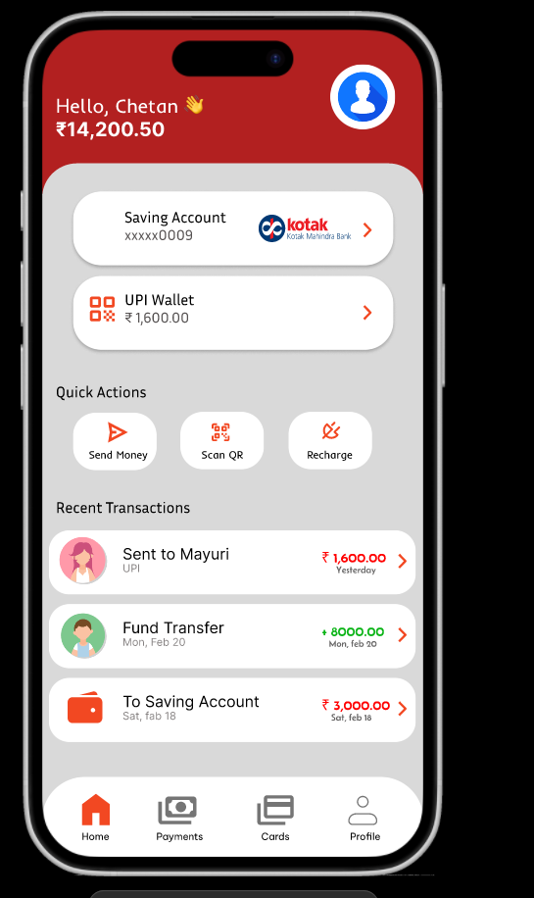

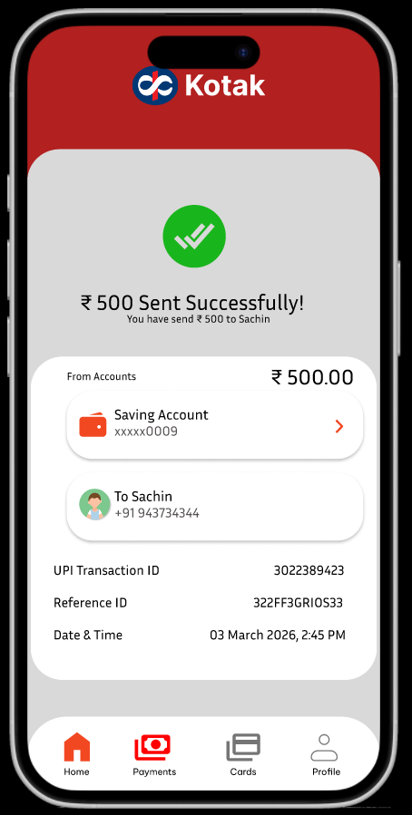

ACE_Project_Chetan Prajapat | Kotak App Redesign

